
Thermometer calibration
Checking the thermometer
Thermometers must be checked every 12 weeks to make sure that they are providing accurate temperature readings, or whenever there is reason to think the thermometer is not working correctly.
How to do the ice point check - this check is to be done if the thermometer is used for checking cold foods.
1 Half fill a glass with broken or shaved ice - you can scrape some ice from the side of a freezer.
- Add a small amount of water until it is visible at the bottom of the glass.
- Insert the thermometer into the mixture, leave until the temperature display is steady.
- Do not let the thermometer touch the sides or bottom of the glass.
- Record the result in the table below. If the result is outside the range, write down the action taken in the table.
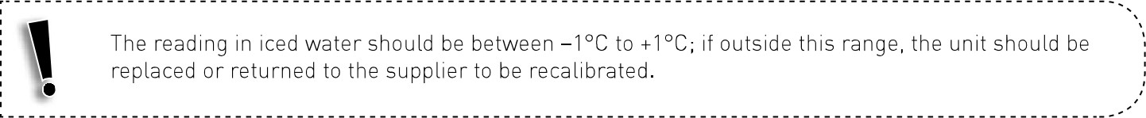
How to do the boiling point check - to be done only if the thermometer is used for checking hot foods.*
- Boil unsalted water in a pot.
- Once boiling, insert thermometer and leave it until the temperature display is steady.
- Do not let the thermometer touch the sides or bottom of the pot.
- Record the result in the table below. If the result is outside the stated range, write down the action taken in the table.
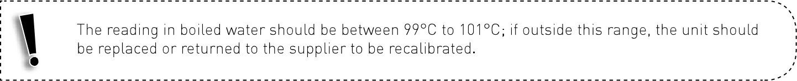

* You may use other validated methods for calibrating a thermometer used for measuring hot foods.
Thermometer calibration record
